XRD-Rigaku Miniflex600

Basic Operation Instruction

Check the water level and switch on the chilling water system and wait for 5mins (Temperature about 70F). If the cooling water level is low, fill the distilled water.

A. Preparing a sample
The following procedure explains sample preparation using a glass sample holder and a powder sample as an example.
- Pour the powder sample into the sample filling section of the glass sample holder.
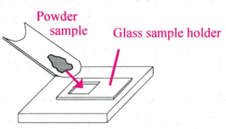
- Flatten and compress the sample surface. Distribute the sample evenly so that the sample surface is flattened and is the same height as the glass sample holder. Gently compress the sample by using the rear side of another glass sample holder.
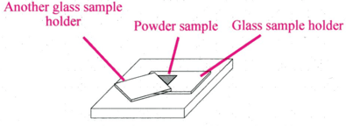
- If the power remains around the filling section, wipe it off by cleaning paper soaked in alcohol.
- Press power on button (green) on the front side of the MiniFlex.
- The door lock button (yellow)will blink 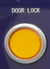.
- Open the sample chamber door and mount the glass sample holder onto the sample stage.
- Close the door and press the Door lock button to lock the door. (Make sure that the operating lamp on the front side of MiniFlex turns yellow 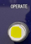.)

B. Setting measurement conditions and starting a measurement.
- Double-click on SmartLab Studio II shortcut icon 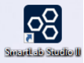on the desktop.
- Wait for < 30sec the instrument initialization and to be Ready.
- Select the XRD Measurement in Plugins tab.
- Double-click the General measurement on the Part Activities list to add it to the Sequence.
- Click the General measurement, that was added to Sequence to open the General measurement dialog box.
- Select Optical conditions and Measurement conditions.

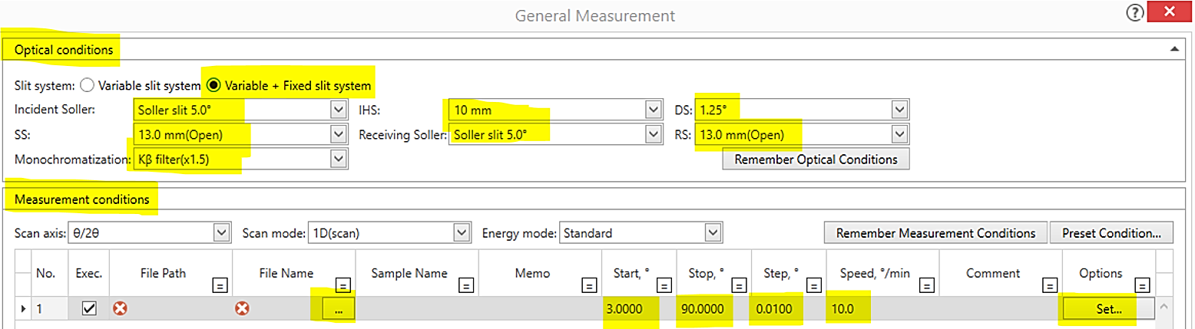
Optical conditions
- Slit system: Variable+ Fixed slit system.
- Incident Soler slit- 5.0 degree.
- Position to insert DS and IHS -1.25 and 10 mm.
- RS:13.0mm (Open)

Measurement conditions
- Click the button to make the file name-choose specify file path(.asc/.xy) and name the name. (Document>User Data> File name)
- Write 2theta value for start and stop conditions, and also for step and speed.
- Set the voltage and current by clicking Set in options. (Recommended 40kV, 15mA)
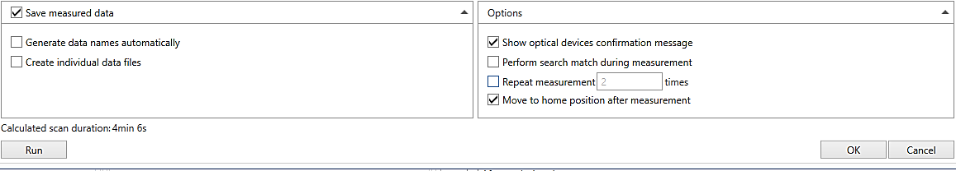
Note: Calculated scan duration occurs. You can save the measurement conditions by checking Save measurement data at the bottom left of the general measurement dialog box.

- Click on Run button to run the program.
X-rays will be turned on, and the tube voltage and tube current will be set to the measurement values. Then the measurement will begin.
Wait for the detector beam measurement.
Note: you can select Use aging table recommended from frequency of use in Startup dialog box.
- Saving the data
Right-click on the profile area, select the Export data and To file and save with .asc/.xy/ file.
Note: The data has already been saved when you make the file. But make sure that you saved the file.

C. Stop the X-ray
- Click the XRD measurement plugin tab.
- Select XG off and click Run button in Startup/Shutdown panel to stop the X-ray generation. 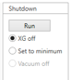
- Wait for <30 sec to turn off X-ray generator.
- Flow sequence completed dialog box will come up, and then click OK.
- When the X-ray generation stops, the orange X-ray warning lamp on top of the encloser will turn off.

D. Take out the sample or changing the sample
Before opening the door, wait at least 5min after X-ray generation stopped.

1. Press the Door Lock button to unlock, open the sample chamber door, and take the sample holder out from the stage.
2. After preparing the sample, mount the glass sample holder on the sample stage.
3. Close the door and press the Door lock button to lock the door. (Make sure that the operating lamp on the front side of MiniFlex turns yellow .)

E. Close the software
- Close the SmartLab Studio II software after saving results.
- Logoff from FOM.

F. Finishing
Before turning off the power, wait at least 5min after X-ray generation stopped.
- Press the power off button (a white button) on the front side.
- Turn off the water chiller by pressing for a while to the power button (OFF).
- Clean the powder inside the chamber and clean the stuff in the working area.

Note
Data Analysis-You can change .asc file path to .raw file using PowDLL converter located on the desktop and then use X’pert high Score Plus in XRD analysis computer (password 532b) in room 532b MMCL.You can use Logging and Materials manager to check XRD task in Rigaku and to reference materials information, respectively.
To refer to Help or detail instruction manual, click the Home tab - 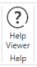 button.

Data Analysis

A. Powder XRD
1. Select the Powder XRD plugin tab in SmartLab Studio II.
2. Perform loading.
- Select Basic from Task on the flow bar.
- Click Evaluation to expand the evaluation flow.
- Click Load Data to display the Load Measurement Data dialog box.
- Select measurement data and click Open.
- Peak evaluation will be automatically performed. The profile will be displayed on the peak profile view panel, and the refined peak information (e.g., position, intensity, FWHM) will be displayed on the Peak list panel.
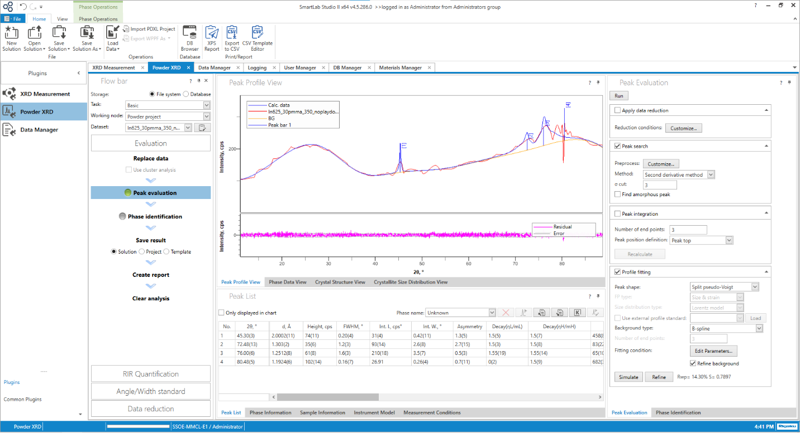
Click on Customize button in Peak Evaluation part and Reset to default data if you want.

- Phase Identification
- Click Phase identification on the flow bar to display the Phase Identification panel and Phase data view.
- Click the Search/March and then click Element Filter to select the elements from Periodic table.
- Make check Optimize diffraction pattern.
- Select phases which correspond the most from search result list, and then added into the Candidate phase list by clicking the down arrow (Add to the candidate phase list).
- Change Candidate phase.
Phases with similar diffraction pattern are grouped together.
  - Click to display the phases.
  - Select of the phase you want to change, and then Click .
- Select the phase name in candidate phase to confirm the data.

- Save result
Select Solution in the save result on the flow bar and then click Save result.
Enter the file name and click the save button. (Select storage type-File system or Database.)

- Create Report
- Click Create report on the flow bar to display the Report parameter dialog box.
- Set the parameters and click OK. The XPS report dialog box appears. Save the data.

B. Data Manager
- Select the Data Manager plugin tab.
- Click the Home tab –Load data on the ribbon.
- Select the measurement data from your file and then click the open button.
- Run the peak search.
- Click the Chart tab.
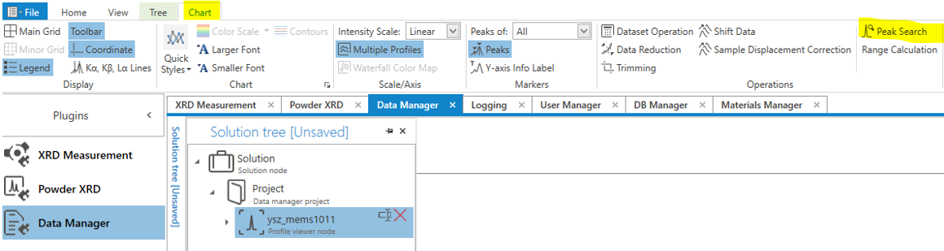
- Click Peak search to display the peak search dialog box.
- Set the Peak search condition and then click Run button.
- Click the Peak list tab( at the bottom left area) to display the peak search results (peak position, intensity, etc.)
- Save the peak search result
- Click the Home tab and click Save Solution As.
- Enter the file name and click Save. (Select File system or Data base)

Emergency Stop
In case of fire or water leak, TURN OFF power using the RED colored Emergency OFF button located on the front side of the instrument. Do NOT remove the key! Avoid this method of shutdown unless absolutely necessary.

