X-ray Analysis-Bruker SkyScan 1272 Micro-CT
Basic Operation Instruction
I. Scanning the sample

A. Sample preparation

B. Starting the SkyScan
Open the SkyScan1272 software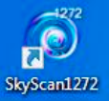 and wait 1-2 mins for ‘Initialization’.
The start image on the screen contains the main menu bar, the toolbar is at the top of the screen, and the status bar at the bottom.
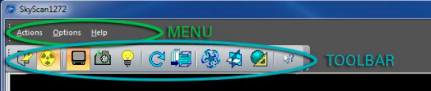
Open/Close specimen chamber X-ray ON/OFF 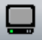 Grab X-ray image continuously
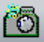 Snap single X-ray image Turn the Visual camera on Start Scanning
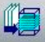 Reconstruction Ct vox (volume rendering program)-movie maker 3 D representation figure
Data viewer CTan/CT vol- CT analysis

C. X-ray ON (Tool bar)
- Click the X-ray ON/OFF button.  - X-ray Source console box will pop up and an indicator 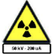appears in the bottom right corner of the screen.  - When the X-ray Source Console comes up, Select X-ray and warm up. | 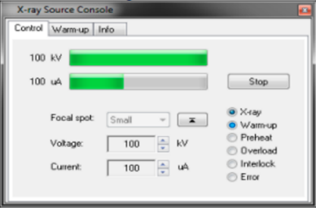
It will take 15 mins to complete the warming-up process. After completing, you can hear the sound.
- Click the Visual camera button to turn the Visual camera on.

D. Setting up the sample
- Click the specimen chamber button to open the door.
- Mount the sample stub in the stage. Make sure not to move the sample but do not over tighten the screw.
- Click on the specimen chamber to close the door. You can see the sample in Camera view.
- Click “Grab Image” button to see the projection image on the screen.

E. Adjust the parameters in the status bar
1. Pixel, 2. Rotation angle of the stage, 3. Elevation/Height, 4. Resolution, 5. Filter

- Select the highest 4. Resolution 4904 x 3280 (1 x 1).  - Move the sample to the center of the display screen using mouse and pressing Ctrl+Alt. | 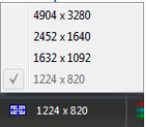
- Select 5. Filter based on the sample’s thickness. (e.g. Metal & thin sample-Cu 0.11mm, thick sample -Al+Cu)  - Select 2. Rotation of the object by clicking on the degree number and typing the number to check the sample scanning position. (View at 90° and then 180°)  - Select 1. Pixel in the status bar to change magnification (e.g. 1.7) | 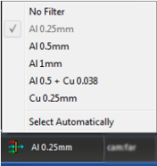
- Select 3. Elevation by clicking on the number 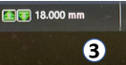.
The box will pop up and set the Elevation, based on the sample holder then press OK.

F. Flat-field correction
- To update flat-field correction, the FOV must only contain air so make sure there is no bed or sample in the FOV.
- Disable flat-field corrections -Flat-field corrections can be enabled (or disabled) by a simple double-click on the top left corner of the image window.
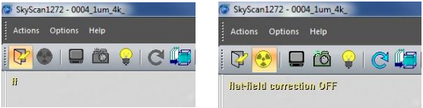
- After flat-field corrections switched OFF, the average profile values should be between 50 - 70%.

Note: If this is not the case, exposure times will need to be changed for the selected mode to get to an average value before acquiring new flat-field corrections. Exposure times can be updated from Options > Scanning Modes as the following instruction.

Scanning mode calibration
- Press these keys combination: Alt+Contrl+Shift+S to activate the scanning mood, and you can hear the beep sound.  - Select the Option at Menu bar. Scroll down and choose the Scanning mode.  - Identify the appropriate exposure time by readjusting the values of voltage, current and camera pixels for the desired filter option. (e.g 90kv,110uA for Cu 0.11mm).  Check mark on –  - Update flat fields for marked modes and modes with modified exposure.  - Use only central camera position.  - Adjust exposure automatically.  - X-ray on after updating and then press OK.  It takes around 30 min for updating the software modes. | 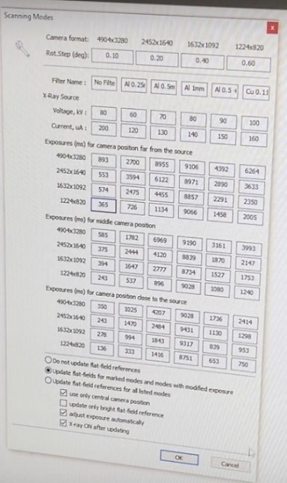
- After the flat-field corrections are acquired, we can enable the flat-field corrections to see the corrected image. The average profile values without any sample in the FOV is around 90%.
- Now the sample can be moved into the FOV by adjusting the elevation to set up the scanning parameters.
- The final image before starting your scan should ideally have a minimum intensity value of 20-40%.

See detailed instructions in MCT-129 document.

G. Scanning the sample  - Click the “Start Scanning” button .  - The control program will open the “Scanning Options” dialog to adjust scanning parameters.  - Choose the location for storage for the projection image files: Click Browse button and save the file in New Volume (E:).  - Rotation step (deg)- 0.1-0.3.  - For first attempt use Averaging (frames) as 2-4.  - Random movement- 30 and check mark on X-ray OFF after scanning. All other checkboxes unchecked.  - Use largest pixel size depending on image, Set Partial width 100% and check Standard scan in central camera position.  Note: Remind the Estimated scanning time, Dataset size and Free disk space.  - Click on Scan. Progress dialog box will pop up.  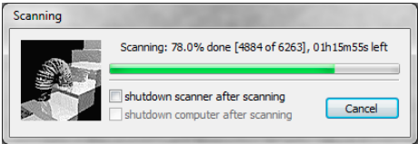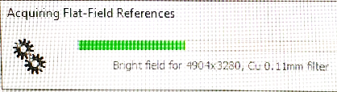  If Delay before scan box will pop up, Skip it. |  | 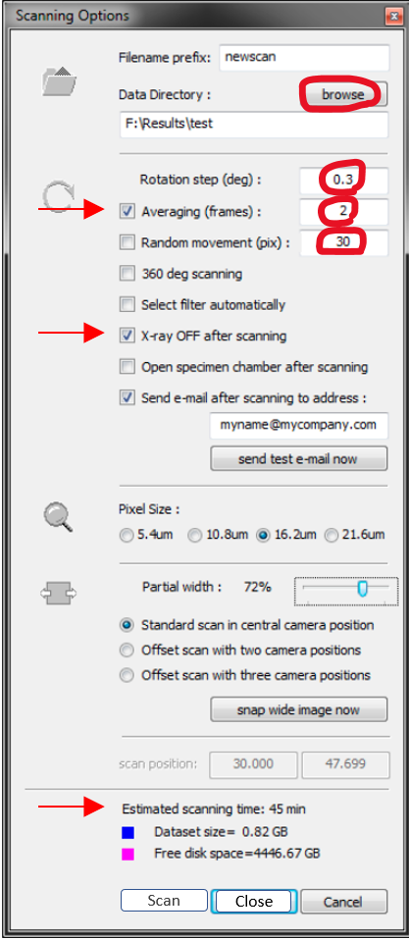
Keep the computer open, and don’t log-off from FOM while scanning.

H. Taking out sample
After the scanning process is completed, click the specimen chamber button to open the door and then take the sample stub from the stage. Click on the specimen chamber to close the door.

II. Reconstruction the image
A. Starting the reconstruction software  Open the GPU reconstruction software. The server window will pop up and minimize it.  Open the N Recon software 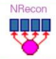 . | 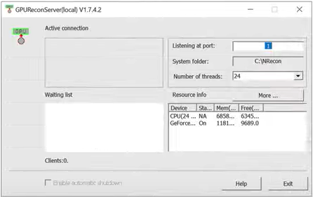

B. Loading Dataset into NRecon
- Navigate to your folder in New Volume (E:). Don’t click on Error file, click on the reference file.
- Wait for <30sec to finish the process.
- After the data set is fully loaded, the shadow projection image will be displayed on the screen and Reconstruction panel can be seen on the top right corner.
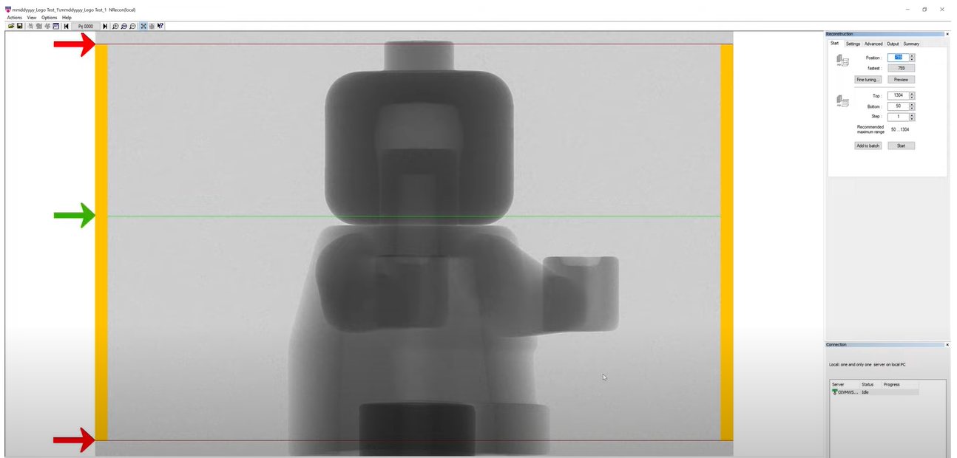  C. X/Y Alignment With a Reference Scan  Click on Actions at Menu bar.  Select the 2. X/Y Alignment With a Reference Scan.  The window will pop up at the right side.  Set the data: a. Max. x-shift from start point (e.g 50)  b. Max. y-shift from start point (e.g 50)  c. Projection pairs to match Section Onward- choose Selection Inward  Click on Match and wait. (You can see the time.)  If the set number (50) changed, d. Estimated shift (x,50). Click Accept buttom. | Note: Red lines represent the upper and lower boundaries of image to be reconstructed and green line refers the level for a single cross-section  image.  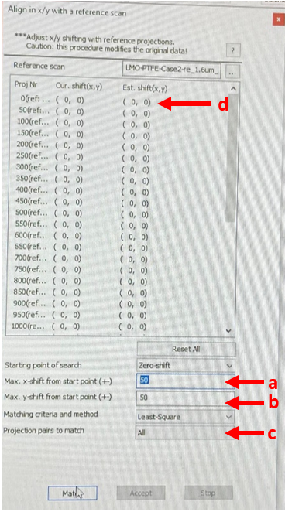
D. Reconstruction  a. Start (Select the image position  - Select “Start” tab in Reconstruction panel.  - You can adjust the green line and red line position in the panel. OR  - You can manually set the number. *  - Press the “Preview” button to see the tested cross-section image projection.  - A progress dialog will appear and wait for < 30sec. Then the cross-section image that you selected by the green line area will show up. | 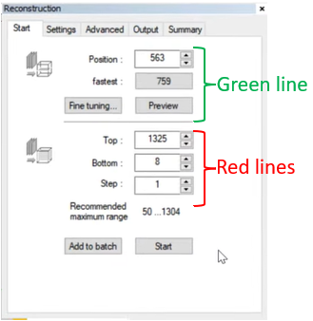
Note: You can check your cross-section image by pressing “Preview” button after any changes.

- Press the “Fine tuning” button to change the parameter.  - The parameter window will pop up. You can attempt 4 parameters by changing steps and trails to get the perfect image (To avoid ring artifact).  - Click Preview. |  | 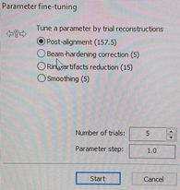
- Click ‘Output’ tap can be seen in the Reconstruction panel.  You can change the min and max density of pixel using the line in histogram. *  - Use mouse to move the contrast limit lines. OR  You can also set the contrast limit by the box under the histogram. *  - Check ‘Use ROI’ box to select the region of interest. Select the shape of the image in the drop-down menu. |  | 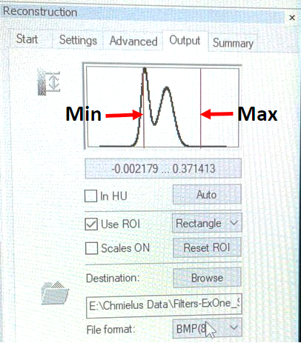
- Click Browse button to save the file. Select the file format. (e.g. BMP). Click Preview.
Click Setting tap in Reconstruction panel to set five reconstruction parameters.  - Check Smoothing and set the number (3-5). *  - Check ‘Misalignment compensation’ and Show. Set the number (40-80). Click the Show/hide profile window button on the tool bar to check misalignment position. *  - Check Ring Artifacts reduction. *  - Beam hardening correction* |  | 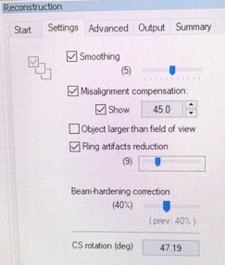
- Cross-section rotation (deg)- e.g 47.19. Click Preview.
- If you are satisfied with your preview image, go back to Start tab, and click ‘Start’ to initiate the reconstruction. Wait for 2mins to complete the process.
- Ring artifacts can be seen within the image.
- For the analysis, choose the area in which ring artifacts were not included.

