Optical Microscope-Keyence VHX 970
Basic operation guide

Warning:
- Ensure that there is no object on the scanning stage before setting up the microscope.
- When changing the camera and light, handle carefully and fix properly.
- After testing, don’t forget to turn off the microscope, turn the console power off and log out from the FOM.

- Introduce Microscope-Keyence
- There are Manual and automatic microscopes.
- Keyence VHX 600- Manual stage with Z20 and Z100 lenses- Magnification (100x-1000x).
- Keyence VHX 970- Automatic stage with Z500, Magnification (500-5000).
- Components- Computer, Stage, measurement unit with the clicky button and Camera, Stage

- Starting the auto-stage microscope
- Ensure that there is no object on the scanning stage before setting up the microscope.
- Switch on the microscope (Monitor) and wait 3-5mins to start window.
- After the window screen pops up, turn on the measurement unit, open the VHX 970 software and wait for initialization of the stage (< 1 min).
- Remove the lens cover.

- Setting up the sample (White balancing)
- Lift up the lens to get enough space between lens and stage for setting up the sample.
- Place the white balance sample on the scanning stage.
- Press White balance button at the console measurement unit.
- Click on 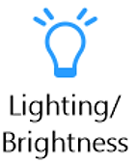 button and click 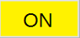 for full ring 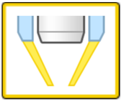 and Lighting unit.
- Focusing the image
For Z direction, use rotation knob of microscope OR use the large and small knobs at the measurement unit control.
For XY direction, use rotation knob of the microscope.
If you get the clear image for white sample, press again White balance button in the measuring unit to finish testing.

- Acquiring the image
- Lift up the lens to get enough space between lens and stage for setting up the sample.
- Place the sample on the scanning stage.
- Choose the microscope lens power.
- Focusing the image- For Z direction, use rotation knob of microscope OR use the large and small knobs at the measurement unit control.
- For XY direction, use rotation knob of the microscope.
- Make sure scale bar to be correct based on your selected lens using the arrow bar 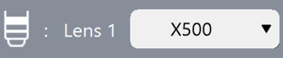 located on the bottom right area of the screen.
- Select button to choose the best image from 9 options.

- Click 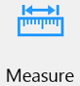 button to choose the tool for plane measurement.
- In Depth up 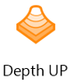 - There are 3 options: Fine depth composition, Manual 3D composition and Quick composition and 3D. Choose one and follow the instructions.
Recommended number of images-(50-70)

- Click button to get the image.

- Saving data
Click on button and save the data in User data: Hard disk\Data folder\User data.

- Finishing
Lift up the lens to get enough space between lens and stage for taking out the sample.
Close the software. Cover the lens cap.
Switch off the computer and turn off the measurement unit.
Don’t forget to log out from the FOM.

Using manual stage
You can set up the desired degree using the handle degree.
Release the rotation screw and taking out the pin to adjust the degree.
After testing, please get back the original position (0 degree) of the handle.

